EE3060 Probability – Proposed questions and answers

Question 1:

The coefficients of the quadratic equation x2 + bx + c = 0 are determined by tossing a fair die twice (the first outcome is b, the second one is c). Find the probability that the equation has real roots.

Answer 1:

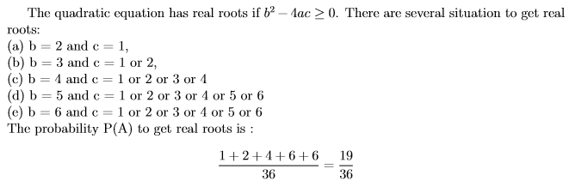

Question 2:

Rolling three fair dice today. What is the probability of rolling the smallest dice point is 2 given that the biggest dice point is 5?

Answer 2:

Subset A represents the numbers of event which the biggest point is five is equal to $n\left(A\right)=5^{3}-4^{3}=61$

The numbers of event $n\left(A∩B\right)$ which is correspondent to the requirement of the problem are

(5, 2, 2) = 3 events

(5, 2, 3) = 6 events

(5, 2, 4) = 6 events

(5, 2, 5) = 3 events

So, the answer goes to $P\left(B | A\right)=\frac{N(A∩B)}{n(A)}=\frac{18}{61}$

Question 3:

For three events A, B, and C, we know that A and C are independent,

B and C are independent , A and B are disjoint ,P(A∪C)=2/3,P(B∪C)=3/4,P(A∪B∪C)=11/12 Find P(A),P(B), and P(C).

Answer 3:

We can use the Venn diagram in Figure 1.26 to better visualize the events in this problem. We assume P(A)=a,P(B)=b, and P(C)=c. Note that the assumptions about independence and disjointness of sets are already included in the figure.

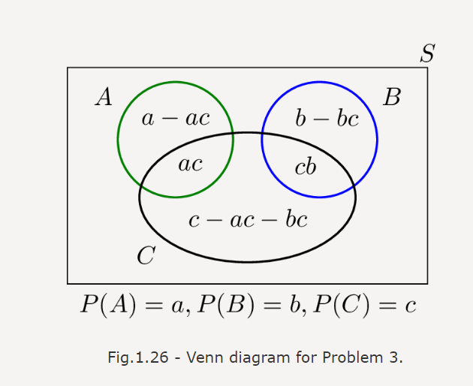

Now we can write

P(A∪C)=a+c−ac=2/3;

P(B∪C)=b+c−bc=3/4;

P(A∪B∪C)=a+b+c−ac−bc=11/12.

By subtracting the third equation from the sum of the first and second equations, we immediately obtain c=1/2, which then gives a=1/3 and b=1/2.

Question 4:

考多重選擇題時，學生可能知道答案，也可能用猜的。設學生知道答案的機率為p，猜答案機率為1-p。假設學生猜對答案的機率是1/m，其中m為選擇題的選項數。若學生答對某題，試求他知道答案的機率為多少?

Answer 4:

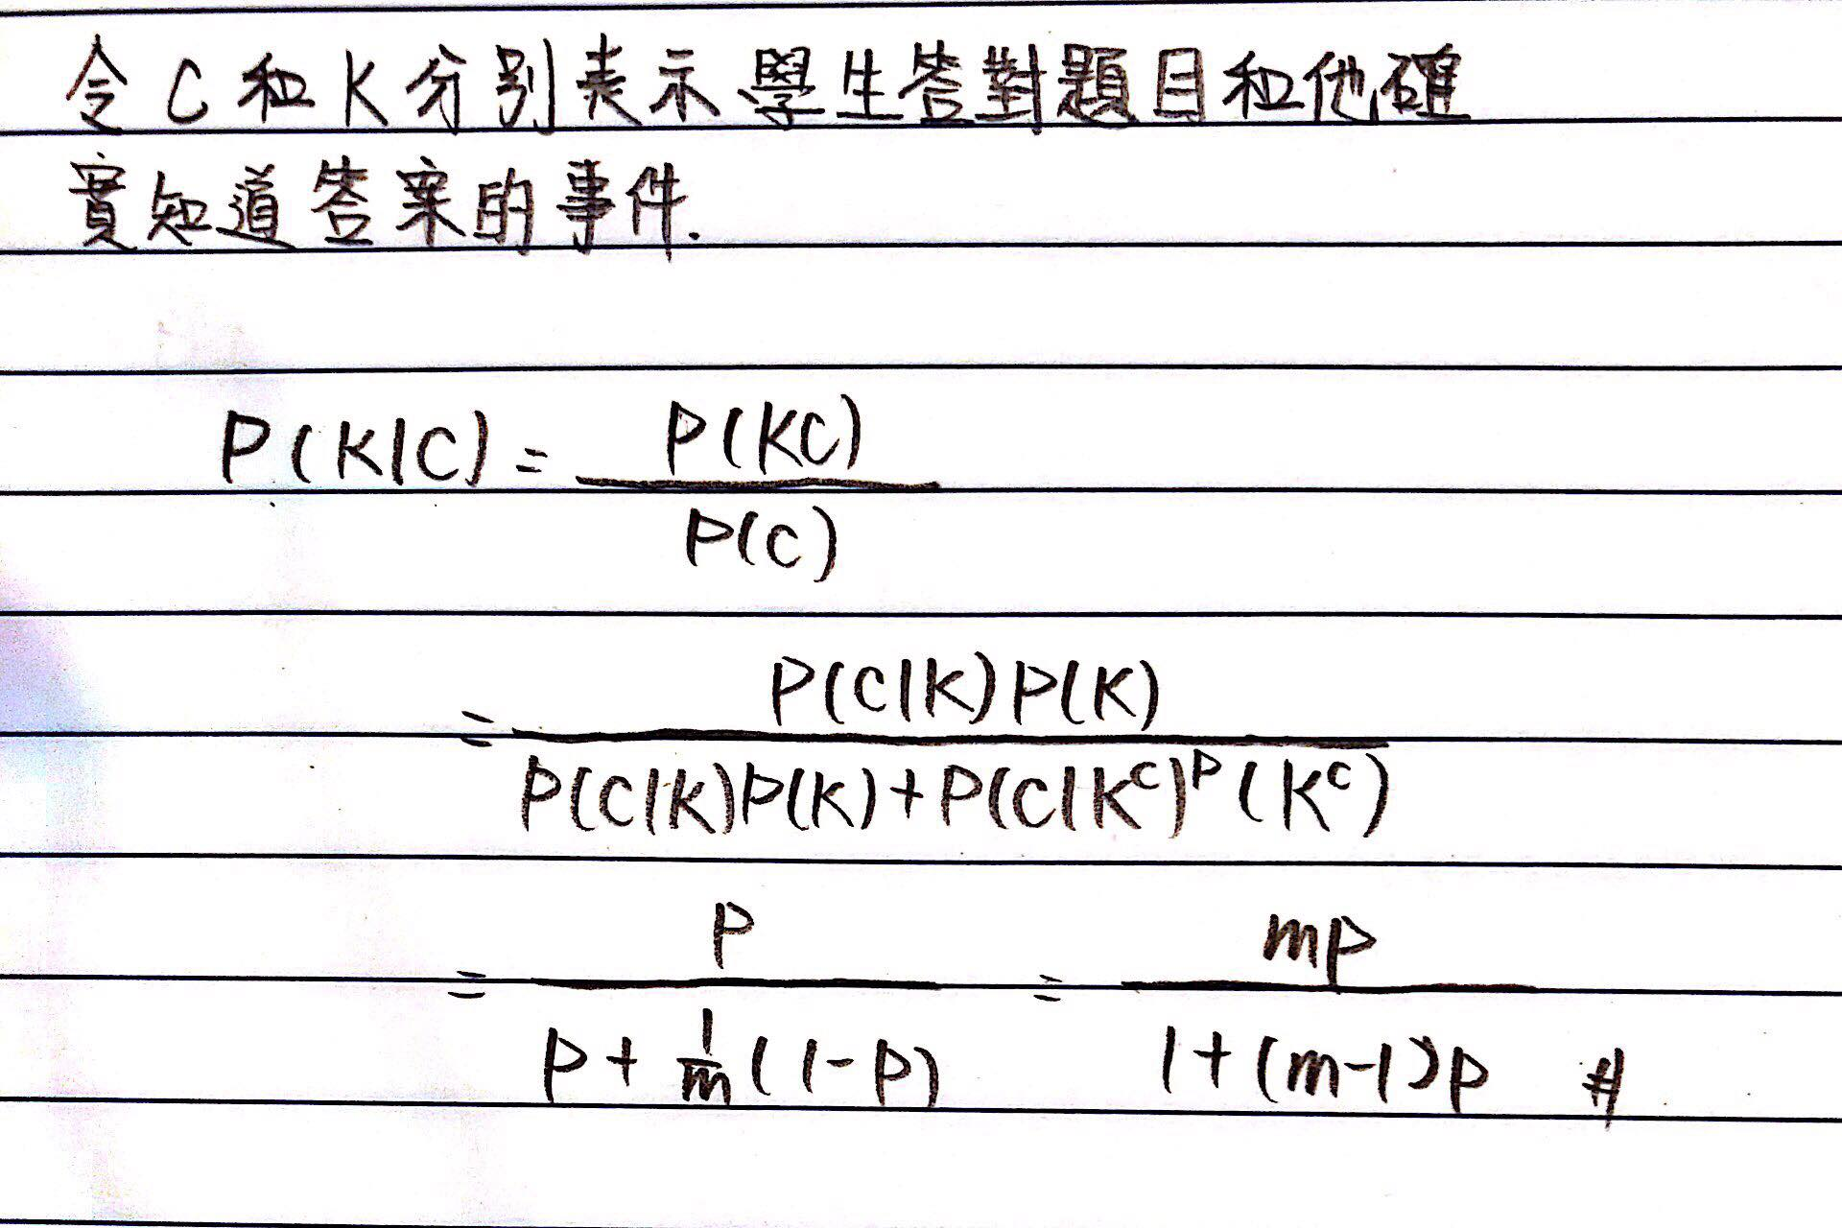

Question 5:

Two persons are playing a match in which they stop as soon as anyone of them wins n games. Suppose that the probability for each person to win any game is 1/2, independent of other games. What is the probability that the loser has won exactly k games when the match is over?

Answer 5: 